LAB REPORT 3 (Exp 3)

1. Based on your observation, record the results in the following table  **(2.5)**

|  |  |  |  |  |
| --- | --- | --- | --- | --- |
| **No.** | **Food product (Test sample)** | **Description of any change(s) before heating** | **Description of any change(s) after heating** | **Are there simple sugars present?** |
| **1.** | **Control**  **(Distilled water)** |  |  |  |
| **2.** | **Apple Juice** |  |  |  |

1. Observe the following diagram and detect which test tube has the highest concentrations of reducing sugar and which one has no reducing sugar. Explain your choice in one or two sentences. **(2.5)**

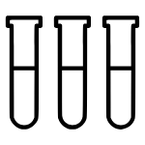

Blue

Brick-red



Yellow

**1**

**2**

**3**